

**PRESS RELEASE** Prague, 28th January 2016

# ALPHA building in Prague’s BB Centrum welcomed new tenants – XEROX CZECH REPUBLIC and GORENJE

**The leading Czech development and investment company PASSERINVEST GROUP is gradually continuing with the revitalisation of the ALPHA building while also welcoming two new tenants. The technology company XEROX CZECH REPUBLIC s.r.o. has moved into the modern office building in BB Centrum in Prague 4, leasing a total of 1028 m2 of office space. Another 561 m2 is being used by GORENJE spol. s r.o., a producer of household appliances. Both companies moved into their new spaces during the course of January and thanks to that the office spaces in the ALPHA building are almost 70% leased.**

The ALPHA building from the Aulík Fišer architekti architectural studio, with 4 underground levels and 8 storeys, was completed in 2003 and Hochtief was the general contractor. The building has a total of 230 parking spots in underground garages that have undergone a demanding reconstruction. *“The goal of the modifications that we made in the ALPHA building was to maintain the high standard of our office buildings in order to continue offering spaces of the highest quality and to meet the demands of new and existing tenants,”* added Štěpán Smrčka, the Head of the Sales Department of PASSERINVEST GROUP, with regard to renovations.

A total of 8100 m2 of the overall 12,300 m2 of office space has currently been leased. In addition to XEROX and GORENJE, which moved into the building as of 25 January 2016, other important tenants include Huawei, DKV and ČEZ.

*“BB Centrum was a wonderful choice for us thanks to its locality and the spaces offered, which fully meet our needs,”* stated Veronika Brázdilová, the General Director of XEROX for the Czech and Slovak republics, with regards for the reasons for the move, adding: “*The building also offers pleasant common spaces including rooftop terraces.”* With regard to GORENJE’s move, Stanko Romih, the company’s Managing Director, stated: “The *ALPHA building appealed to us because of its excellent accessibility and attractive architecture. We see our new address as a breath of fresh air, a step in the right direction. We are sure that we will like being in BB Centrum with all the benefits it offers.”*

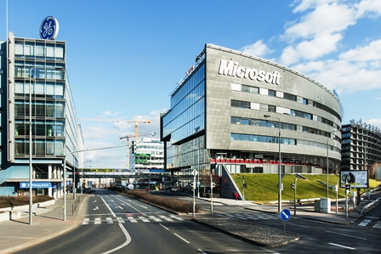

Building ALPHA in BB Centrum

For more information and photographs in print quality please contact:

Kristýna Samková**,** Marketing manager

**PASSERINVEST GROUP, a.s.**

Tel.: (+420) 221 582 111, fax: (+420) 222 515 521

Mobil: (+420) 602 186 708

E-mail: [Kristyna.Samkova@Passerinvest.cz](mailto:Kristyna.Samkova@Passerinvest.cz)

www.passerinvest.cz, [www.bbcentrum.cz](http://www.bbcentrum.cz)

Marcela Štefcová

**Crest Communications a.s.**

Tel.: (+420) 222 927 125

Mobil: (+420) 731 613 669

E-mail: marcela.stefcova@crestcom.cz

**About the Developer**

**PASSERINVEST GROUP, a.s.,** founded in 1991 by Radim Passer, is a purely Czech development and investment company whose name is associated in particular with the **BB Centrum** multifunctional complex in Prague 4 - Michle. With this project, the most successful and extensive Czech project of its type, the company has built its excellent reputation both at home and at the international level. Contributing to this is not only the high quality of the projects completed to date, but also its high level of service, its sense of fair play, its positive relationship with the tenants and users of its buildings, and its sense of responsibility towards society and the environment. **PASSERINVEST GROUP**’sportfolioincludes other interesting development projects.